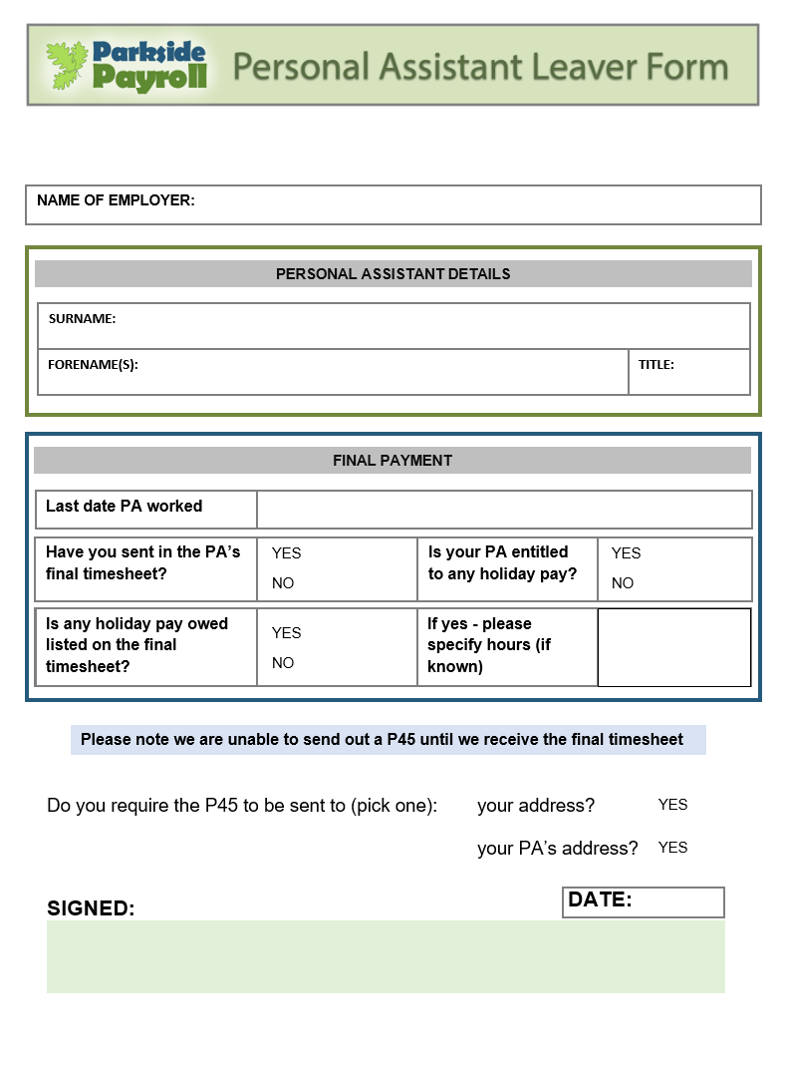

|  |  |
| --- | --- |
|  | Click to write the name of your employer. |

|  |  |  |  |
| --- | --- | --- | --- |
|  | Click to add your forename(s). |  | Choose |

|  |  |
| --- | --- |
|  | Click to add your surname |

|  |  |
| --- | --- |
|  | Click to choose the date. |

|  |  |  |  |  |  |
| --- | --- | --- | --- | --- | --- |
|  |  |  |  |  |  |
|  |  |  |  |  |  |

|  |  |  |  |  |  |
| --- | --- | --- | --- | --- | --- |
|  |  |  |  |  | Click here to enter text. |
|  |  |  |  |  |

|  |
| --- |
|  |

|  |
| --- |
| Click to sign your name |

|  |
| --- |
| Choose |

|  |
| --- |
|  |